InternetandWebTechnologyLab Dept.ofCSE,SiliconUniversity Assignment2

- Createatabletodisplaystudentinformationwiththefollowingfieldsandinsertatleasttwo studentdetails:RollNumber,Name,Email,MobileNumber,ProfilePhoto
- DesignthefollowingtimetableusingHTMLtabletagsandattributesonly:
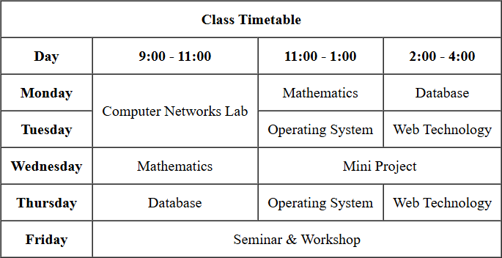

- Createaregistrationformforanonlinecoursewiththefollowingfields:
  - FullName(text)
  - Email(text)
  - PasswordandConfirmPassword(password)
  - Gender(radiobuttons:Male,Female,Other)
  - DateofBirth(datepicker)
  - Course(dropdown:B.Tech,M.Tech,MCA,MBA)
  - Skills(checkboxes:HTML,CSS,JavaScript,Python,Java)
  - Address(textarea)
  - UploadResume(fileinput)
  - SubmitandResetbuttons
- Createawebpagethatdemonstratesmultimediaintegration:
- Embedanaudiofilewithcontrols(play/pause).
- Embedavideofilewithcontrols.
- Create a webpage named My Profile using HTML5 semantic elements. Your page must use appropriate semantic tags (forexample: <header>, <nav>, <main>, <section>, <footer>) and mustsatisfyallofthefollowingrequirements:
- Usea<nav>withanchorlinks(bookmarks)tothesectionsonthesamepage:About, Education, andHobbies.
- Usea<header>elementthatcontainsyournameasthemainheading(<h1>),yourphone number and your email.
- Usea<main>elementtowraptheprimarypagecontent.
- Createthree<section>elementswithidattributesabout,education,andhobbies.Each sectionmusthaveaheading(<h2>)andatleastoneparagraphdescribingthetopic.
- Intheaboutsection,includeyourprofileimageandaparagraphaboutyourself.Usealist to showcase your skills.
- Intheeducationsection,useatabletoshowcaseyouracademicrecords.
- Inthehobbiessection,addalistofhobbies.
- Thefootersectionmustcontainhyperlinkstoyoursocialmediahandles.

